TO: *Dr. David Green*

FROM: *Adam Fuller, Isaiah Chamoun, Lawrence Oldham (alfull16, ichamoun, oldhaml)*

DATE: *27 NOV 2018*

SUBJECT: *EE-333 User Interface Design Document*

Summary

The backend code of our HVAC System is intended to simulate an HVAC system with variable disturbances to the rooms. It contains objects that are representative of the components in the system and build that it is contained in. These objects include but are not limited to: Heater, Cooler, Blower, Room, Floor, Building, Controller, Clock/Time, and Temperature Sensor. Each of the previously named objects is intended to simulate a corresponding component of a building or HVAC system. Our target product is going to be a visual simulation of the temperatures and state of each room and its HVAC components. The product should allow for the user to input the temperature for each room, add rooms, and add floors, deleting floors and rooms would be very beneficial. The simulation should capable of pausing, starting, saving its progress to a file, and resuming at a later time from a save file. The program should have the temperatures of the rooms be affected by an ambient temperature array that represents the temperature outside of the building.

# MILESTONES

* Present Command Line Utility
  + Date: Completed
* Create graphical representation of GUI
  + Date: Completed
* Present GUI Design to class
  + Date: Completed
* Adjust GUI design based on feedback
  + Date: Completed
* Submit UI Design Document
  + Date: 27 November
* Create GUI in Java
  + Date: 31 November
* Present Java GUI to class
  + Date: 11 December
* Submit Java GUI with final project
  + Date: 11 December

# TASKS

# Startup

* Identify Modeling Objects
  + SN: TS001
  + Person: Lawrence
  + Time: 30 min.
  + Priority: Useful
* Identify I/O Objects
  + SN: TS002
  + Person: Lawrence
  + Time: 30 min.
  + Priority: Useful
* Create Modeling Classes
  + SN: TS003
  + Person: Isaiah
  + Time: 15 min
  + Priority: Useful
* Add Functionality to, finalize, modeling classes
  + SN: TS004
  + Person: Isaiah
  + Time: 1 hour +
  + Priority: Critical
* Create I/O classes
  + SN: TS005
  + Person: Adam
  + Time: 15 min
  + Priority: Useful
* Add Functionality to, finalize, I/O classes
  + SN: TS006
  + Person: Adam
  + Time: 1 hour +
  + Priority: Critical

***Command Line***

* Agree on Command Line utility functionality
  + SN: TCL001
  + Person: Team
  + Time: 15 min – 1 hour
  + Priority: Useful
* Plan Command Line utility
  + SN: TCL002
  + Person: Isaiah
  + Time: 30 min
  + Priority: Important-Useful
* Create Command line utility
  + SN: TCL003
  + Person: Adam
  + Time: 1 hour +
  + Priority: Critical

***GUI***

* Plan GUI Design (interactions and capabilities)
  + SN: TG001
  + Person: Team
  + Time: 30 min
  + Priority: Important-Useful
* Begin GUI Design
  + SN: TG002
  + Person: Adam
  + Time: 30 min +
  + Priority: Useful
* Finalize GUI Design
  + SN: TG003
  + Person: Team
  + Time: 15 min
  + Priority: Important
* Create GUI in Java
  + SN: TG004
  + Person: Adam
  + Time: 1 hour +
  + Priority: Critical
* Plan GUI-Backend Interaction(s)
  + SN: TG005
  + Person: Lawrence
  + Time: 30 min
  + Priority: Useful

***GUI-Backend Interaction***

* Verify Interaction Viability
  + SN: TGBI001
  + Person: Lawrence
  + Time: 1 hour
  + Priority: Important
* Finalize Interaction Plans
  + SN: TGBI002
  + Person: Team
  + Time: 30 min
  + Priority: Important-Useful
* Code Interactions
  + SN: TGBI003
  + Person: Isaiah
  + Time: 1 hour +
  + Priority: Critical

***Testing***

* Testing
  + SN: TT001
  + Person: Team
  + Time: 2 hours +
  + Priority: Critical-Important

Make more Milestones and Tasks

# Figures and Tables

|  |  |  |  |  |  |  |
| --- | --- | --- | --- | --- | --- | --- |
| Type of Risk | Area in Jeopardy | Description of Risk | Expectation of Risk | Impact | Severity | General Action Plan |
| Incorrect User Input | Quality | User inputs invalid options or parameters for text areas | 3 | 9 | 27 | Account for incorrect user input in the code. Prompt the user when improper inputs are detected |
| Beta-lock | Schedule | Consistently wanting to add new features prevents final release of product. | 2 | 9 | 18 | Ensure proper milestone completion and restriction of new milestones and features. |
| Invalid Save File | Quality | The user is attempting to load up a file that doesn't work with our program | 3 | 4 | 12 | Prompt the user that the input file doesn't work. |
| Component doesn't switch on/off | Quality | Unexpected system failure will affect the performance of the simulation. | 1 | 6 | 6 | Ensure the code works properly, inform the user of how it works. Include a safety net. |
| Failed Interaction | Quality | Interactions between the ambient temperature and rooms fail. Any component interactions fail. | 1 | 6 | 6 | Ensure the code works. |
| GitHub Failure | Schedule | Github crashes or the repository is lost. | 1 | 2 | 2 | Everyone keeps and maintains a recent copy of the code. |

Table 1. Risk Management Matrix

# GRAPHICS

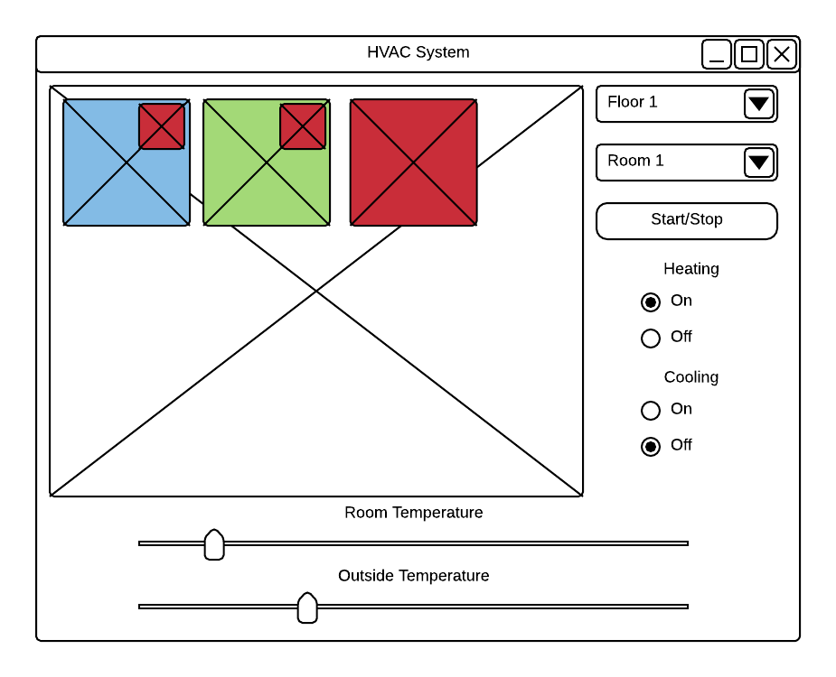

Example Starting Screen

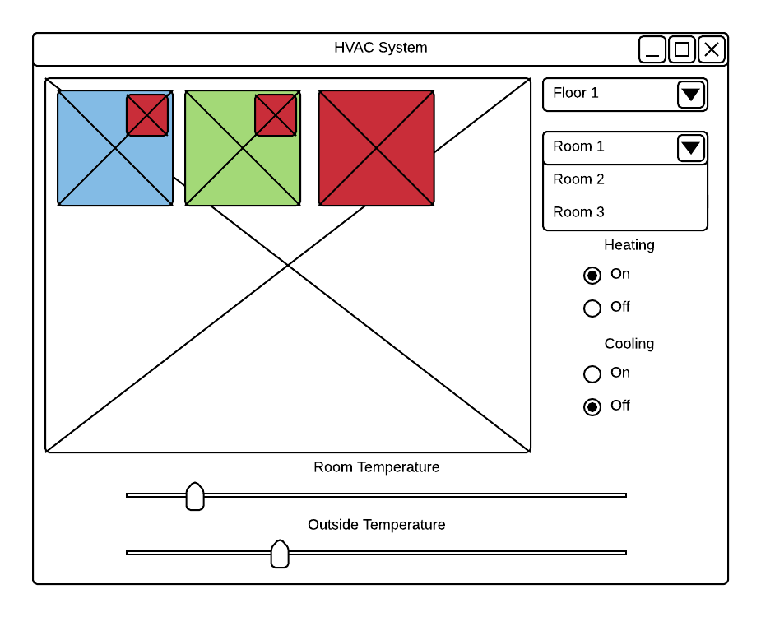

Room Selection Drop Down Menu

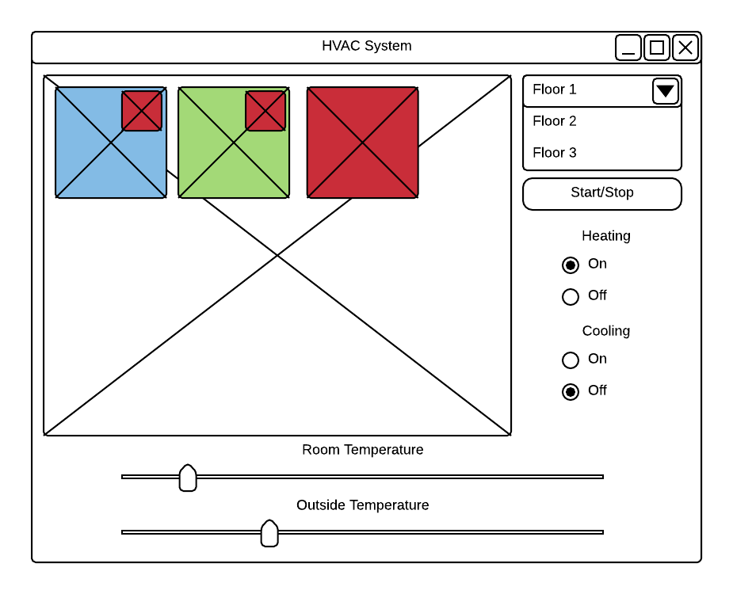

Floor selection Drop Down Menu

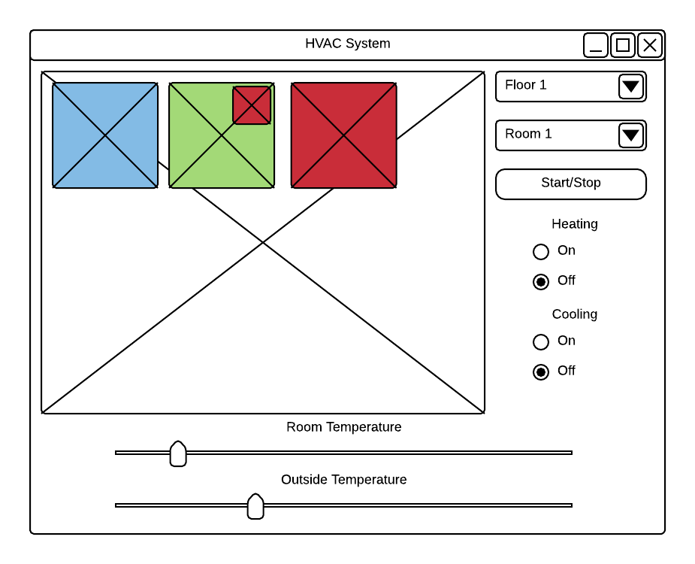

Heater Radio Button Changes

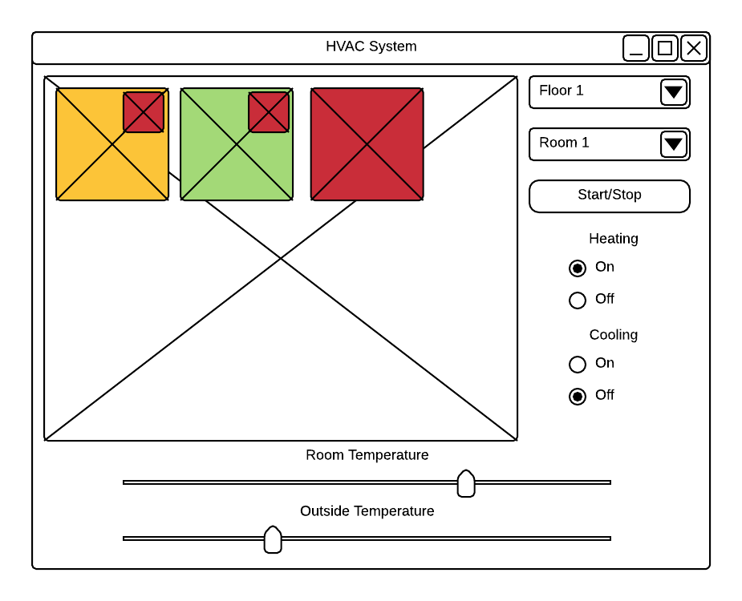

Adjusting Temperature of Room 1

# INTERACTIONS

* Scenario 1. Switching Rooms
  + The user can click on the room they desire to select.
  + The user can click on the dropdown menu to view the rooms and pick the number of the room they want to adjust.
* Scenario 2. Adjust heater and cooler
  + The user can select the radio button to turn the heater on or off.
  + The user can select a radio button to turn the cooler on or off.
  + Turning the heater on turns off the cooler and vice versa.
* Scenario 3. Change Floor
  + The user can select the dropdown menu to adjust the current floor they are viewing.
* Scenario 4. Adjusting Room Temperature
  + The slider on the bottom labeled “Room Temperature” can be used to adjust the selected room’s temperature.
* Scenario 5. Adjusting Outside Temperature
  + The slider on the bottom labeled “Outside Temperature” can be used to adjust the outside temperature
* Scenario 6. Starting and Stopping the Simulation
  + The “Start/Stop” button is pressed causing the time in the program to start running again.

References